**2017 Public Benefit International Challenge for Youth （PBIC）**

|  |  |  |  |  |  |  |  |  |  |
| --- | --- | --- | --- | --- | --- | --- | --- | --- | --- |
| Name (Chinese) | Name (English) | School | Gender | Birthdate | ID No. | Contact Information | Email Address | Parent(s) Name | Parent(s) Contact Information |
| 杨思达 | Star | NCPA | 女 | 2001／09／30 | 440102200109304021 | 18026395457 | [starstellabobby@126.com](mailto:starstellabobby@126.com) | 梁青 | 18928711837 |
| 赵子曦 | Albert | NCPA | 男 | 2002/10/5 | 440602200210050019 | 18033244500 | [319734082@qq.com](mailto:319734082@qq.com) | 赵青 | 18033244100 |
| 陈洁 | Catherine | NCPA | 女 | 2000/11/14 | 440682200011146327 | 13392750621 | [chj124133@126.com](mailto:chj124133@126.com) | 张家连 | 13923185052 |
| 陈奕帆 | Richard | NCPA | 男 | 2001/10/21 | 320104200110210810 | 15917006945 | [2211270453@qq.com](mailto:2211270453@qq.com) | 金燕 | 13760972221 |
|  |  |  |  |  |  |  |  |  |  |
|  |  |  |  |  |  |  |  |  |  |

**\*All of the above information must be true**

**Agreement**

**Agree and support 440102200109304021 440602200210050019 440682200011146327 320104200110210810 ID No.) ______________________）To part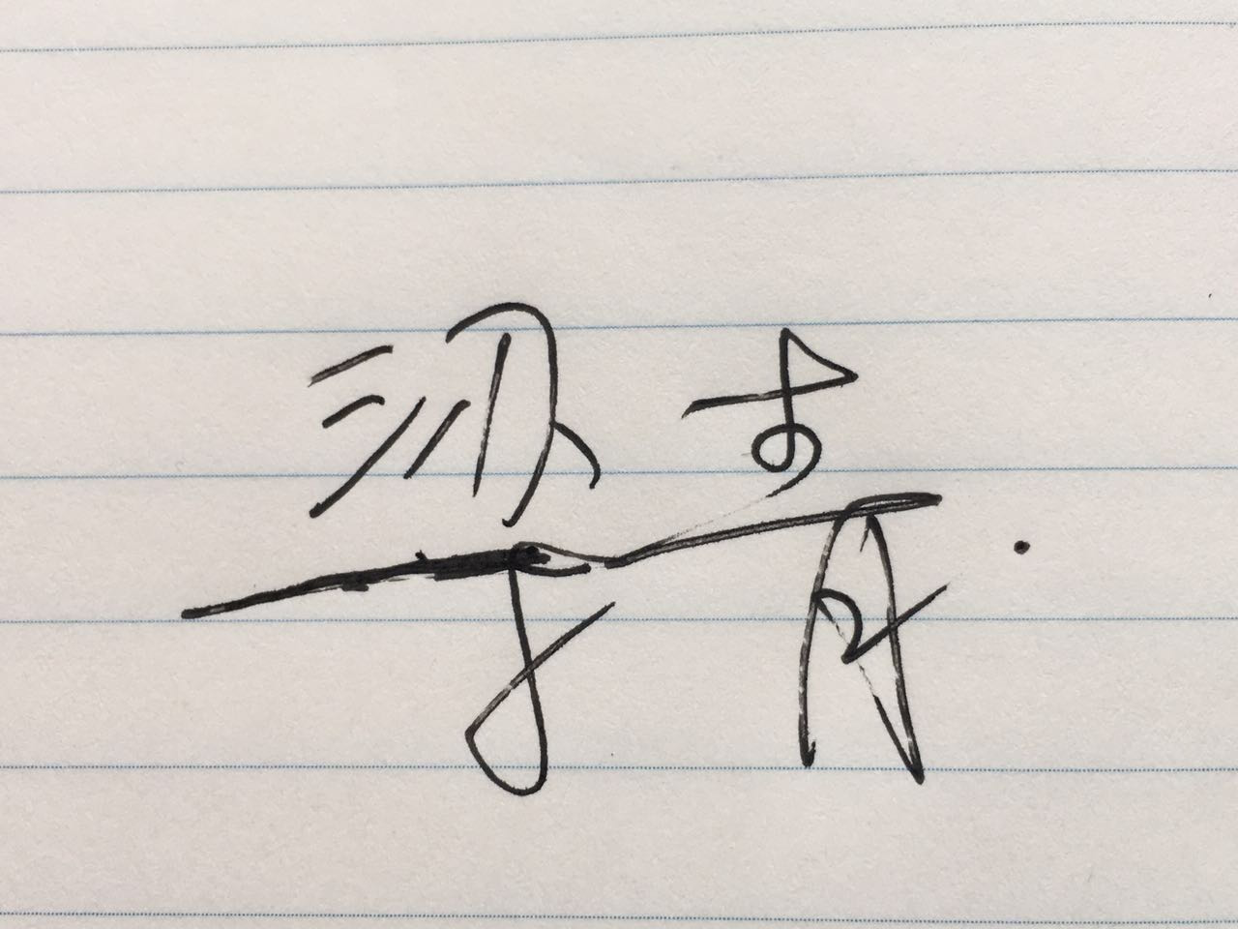icipate in the 2017 PBIC Event.**

**Parent(s) Name(s): _**梁青**_______________**

**Parent(s) Signature(s): _____________**

**Date: ___2017/06/22_______________________**