2017 Public Benefit International Challenge for Youth （PBIC）
Name (Chinese) | Name (English) | School | Gender | Birthdate | ID No. | Contact Information | Email Address | Parent(s) Name | Parent(s) Contact Information
万子朴 | Chiver Wan | 华南师范大学附属中学 | 男 | 2000.12.07 | 440508200012074610 | 13710299717 | 1123042730@qq.com | 徐丽 | 13533399891
胡宸瑞哲 | Leo Hu | 华南师范大学附属中学 | 男 | 2000.11.23 | 211403200011238610 | 13544459672 | hucrz.leo2016@outlook.com | 陈见春 | 13676266400
曾睿扬 | William Zeng | 广州市南沙区NCPA美式高中 | 男 | 2002.6.17 | 440105200206170917 | 13822238505 | 20wzeng@ncpachina.org | 杨菁 | 13719348505
庞玥茵 | Christine Pang | DVHS | 女 | 2001.05.17 | 440104200105172220 | 18198915671 | 1104599496@qq.com | Pang Jianhui | 13924108383

*All of the above information must be true

Agreement

Agree and support _____万子朴_____（ID No.) 440508200012074610）To participate in the 2017 PBIC Event.

Parent(s) Name(s): ________徐丽________
Parent(s) Signature(s): ___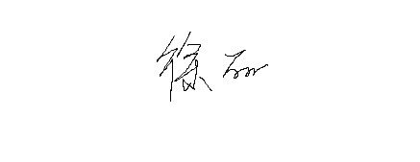__________
Date: 2017/7/9__________________________

